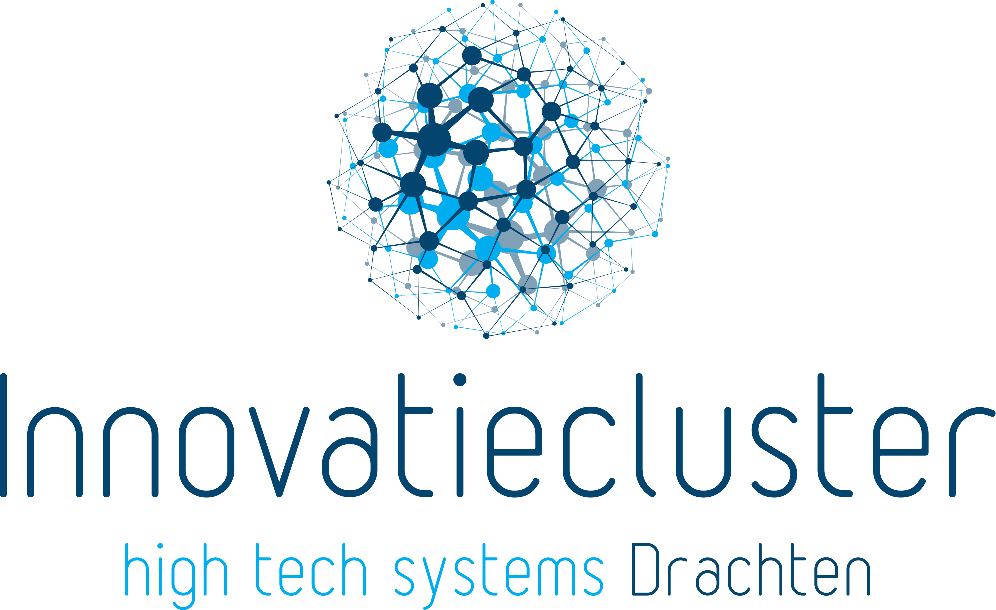

INNOVATIECLUSTER ALGEMEEN

We are Innovatiecluster Drachten, a group of high-tech companies located in the north of the Netherlands. We are at the forefront of technical innovations in products and solutions worldwide.

We work together instead of competing. By sharing knowledge, we create high-quality and unique products. New insights are most welcome and we enjoy collaborating with technical talented people.

We believe in content and gladly share our knowledge. We do this by organising honours programmes for students and high-tech Safaris. We also host special career and development programmes for talented people and supervise high-tech start-ups.

Our companies feature a high-tech Shared Facility Centre, including industrial metal and plastic 3D printers and cobots. This is also where our workshops for R&D projects take place, and development and testing facilities for 3D printing and auditoriums for school and student programmes are located.

Big 5

We work together on providing solutions for the future, by combining our 'Big 5' of high-tech: robotics, metal 3D printing, remote sensing and big data, visual intelligence and renewable propulsion. A few examples:

- A healthy living environment, through renewable energy and smart solutions for reducing fossil fuel in transport.
- Remote sensing and big data; remotely connecting devices, instruments and machines to collect, transfer, store, analyse and act on data.
- Healthy and safe food for everyone, by using sensors and big data to monitor and improve the quality of food and drinks.
- Visual intelligence; a unique combination of camera techniques, big data and neural networks.
- Better healthcare, helping doctors to recognize diseases faster and better by using smart software.
- A safer society, in which visual intelligence and big data help prevent child pornography and terrorist attacks.
- Healthy working conditions, by using 3D printing and robots to make work cleaner, safer and easier.

Together we create more than 50 new products a year worldwide, and contribute to society by saving lives, making complex systems easy to operate, providing access to data that improve food quality, and tailoring products to individual consumer needs.

Smart Industry Hub

We stimulate the digitisation of companies in the northern region. We do this in our Skills lab, which is part of the Smart Industry Hub Northern Netherlands. We help large and small companies to improve their products, services and processes by showing them the benefits of 3D printing, remote sensing & big data, vision & deep learning and robotics. These technologies form the basis for co-creation with other disciplines, research, open innovation and education. This way, business and growth are aligned with sustainable development.

We accelerate digitisation of our regional economy with the following tracks:

- Go Digital': companies are aware of digitisation and the associated competences
- 'Play the Champions League': we connect our frontrunners to EU innovation programmes and share our competences with additional regions
- 'Create and share talents and competences' with three demo factories or skills labs
- Private Public Partnership (PPP), a non-profit partnership.

Exchange

Knowledge exchange is the basis of our cooperation. This attracts the attention of schools. University of Groningen, University of Twente, the colleges NHL/Stenden, Hanze University Groningen and the ROCs Friese Poort, Friesland College and Drenthe College have now joined in. Not only to conduct research, but also to gain work experience through an internship in a high-quality technical environment.

Working at Innovatiecluster Drachten means contributing to solutions for the future. More than 3,500 motivated professionals, from academics to production workers, have chosen a career in the high-tech industry with us. Together they find it a challenge to develop high-quality and unique products with each other's knowledge and to produce them themselves. This is possible because competition has made way for each other.

Technology industry

In addition to the focus on private R&D in the north of the Netherlands, we form a high-quality high-tech manufacturing industry that is unique for North-Western Europe. It attracts people who want to build their career in a future-oriented high-tech industry. It is also attractive for high-tech companies that can gain a competitive edge by sharing knowledge and making use of each other's facilities.

Knowledge

Through cooperation based on knowledge exchange, a unique high-tech ecosystem is growing in the north of the Netherlands. Knowledge institutes are joining forces, including the universities of Groningen and Twente, the northern universities of applied sciences NHL and Hanze University of Applied Sciences and ROC Friese Poort. Not only for carrying out research, but also to gain work experience through internships in a high-quality technical environment. In addition, we run facility-sharing programmes, special career and talent development programmes for both secondary vocational education (MBO) and higher education (HBO/university) graduates, and we supervise high-tech start-ups.

Contact information
Oliemolenstraat 5
9203 ZN Drachten
info@icdrachten.nl
https://www.icdrachten.nl/en/

www.partofthesmart.nl

Social Media
LinkedIn

Instagram

Facebook
Twitter

